Name | Vaishnavi Panmand
Roll no | 24204C0053
Batch | 3
Subject name | Python Programming & Data Structure
Teacher Name | Ms. Rasika Patil

Experiments | 9
Title | Develop python program to define class Student with data members (Roll no, Name, Course, Percentage) as input and then print the details.

Programming Questions with Answer
1 |  | Program to create a Student class and display details
SCRIPT |  | class Student:  def __init__(self, name, roll_no, course, marks):  self.name = name  self.roll_no = roll_no  self.course = course  self.marks = marks  def display_details(self):  print("Student Details")  print("---------------")  print("Name:", self.name)  print("Roll No:", self.roll_no)  print("Course:", self.course)  print("Marks:", self.marks)  student1 = Student("Rehan", 101, "BSc IT", 85)  student1.display_details()
OP |  | 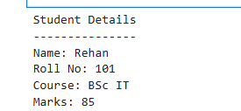
2 |  | Program using constructor to initialize student details
SCRIPT |  | class Student:  def __init__(self, name, roll_no, course, marks):  self.name = name  self.roll_no = roll_no  self.course = course  self.marks = marks  def display(self):  print("\nStudent Details")  print("----------------")  print("Name:", self.name)  print("Roll No:", self.roll_no)  print("Course:", self.course)  print("Marks:", self.marks)  name = input("Enter Name: ")  roll_no = int(input("Enter Roll No: "))  course = input("Enter Course: ")  marks = float(input("Enter Marks: "))  s1 = Student(name, roll_no, course, marks)  s1.display()
OP |  | 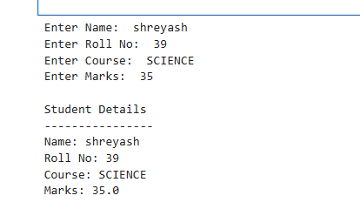
3 |  | Program to take multiple student objects
SCRIPT |  | class Student:  def __init__(self, name, roll_no, course, marks):  self.name = name  self.roll_no = roll_no  self.course = course  self.marks = marks  def display(self):  print("\nStudent Details")  print("----------------")  print("Name:", self.name)  print("Roll No:", self.roll_no)  print("Course:", self.course)  print("Marks:", self.marks)  students = []  n = int(input("Enter number of students: "))  for i in range(n):  print(f"\nEnter details for Student {i+1}")  name = input("Enter Name: ")  roll_no = int(input("Enter Roll No: "))  course = input("Enter Course: ")  marks = float(input("Enter Marks: "))  s = Student(name, roll_no, course, marks)  students.append(s)  print("\n===== All Student Details =====")  for student in students:  student.display()
OP |  | 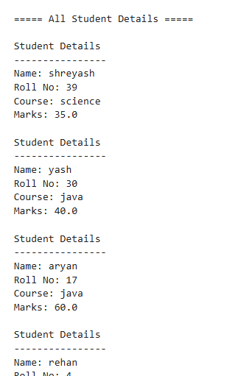
Debugging Questions with Corrected Answers
1 | Debug the following code  Wrong code:  class Student  def __init__(self):  self.name = "Amit"
OP | Error:  class Student  def __init__(self):  self.name = "Amit"  Correct code:  class Student:  def __init__(self):  self.name = "Amit"
2 | Debug the following code  Wrong code:  class Student:  def show():  print("Hello")  obj = Student()  obj.show()
OP | Error: class Student:  def show():  print("Hello")  obj = Student()  obj.show()  Correct code: class Student:  def show(self):  print("Hello")  obj = Student()  obj.show()
Conclusion | This practical helped us understand the basics of class, object, constructor, and self keyword in Python. It improved our knowledge of Object-Oriented Programming (OOP) concepts.
Performance Indicators |  |  | Teachers Dated and Signature
Process Related  (15 M) |  | Product Related  (10 M) | Total (25 M)

